VBA-Scripting Homework

**Stock Market Analysis**

While scripting, It return error for 2015 and 2014 sheets. Further investigation reveals, that this is caused by the dataset of PLTR.

In 2015, PLTR dataset opening value was equal to zero on the first recording date. Then after few days/rows it has the opening value. From this point to 2016 there were no issues on the data. For 2015, I used the opening value on the date where the opening value was recorded, 20150806. While keeping the closing date as the last recorded close date.

I have used If function to find the location of this unusual data set by based on conditional PLTR’s opening/closing position. I have marked with red font on the result grouping.

In 2014, PLTR dataset was all 0, Hence all the result, for yr change and % change will be 0. Similar approach with 2015 sheet, if function have been used to locate and highlighted this.

There were no irregularities for 2016 dataset.

2014

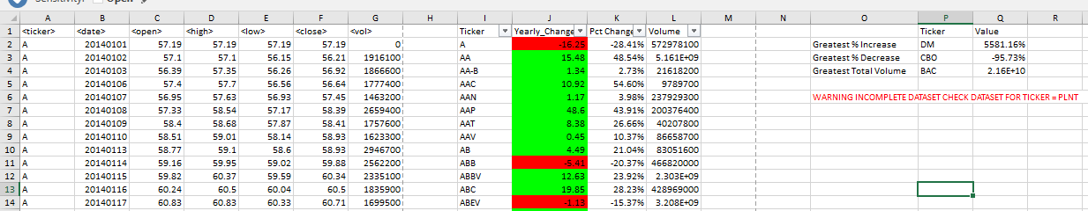

2015

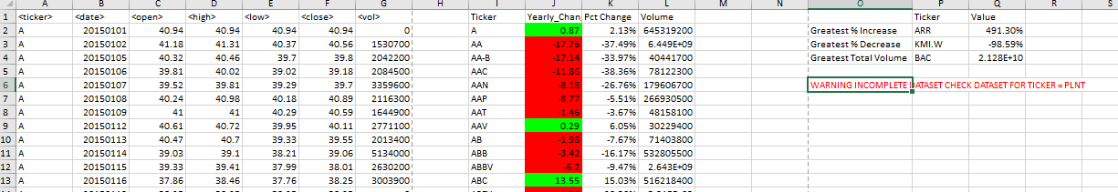

2016

